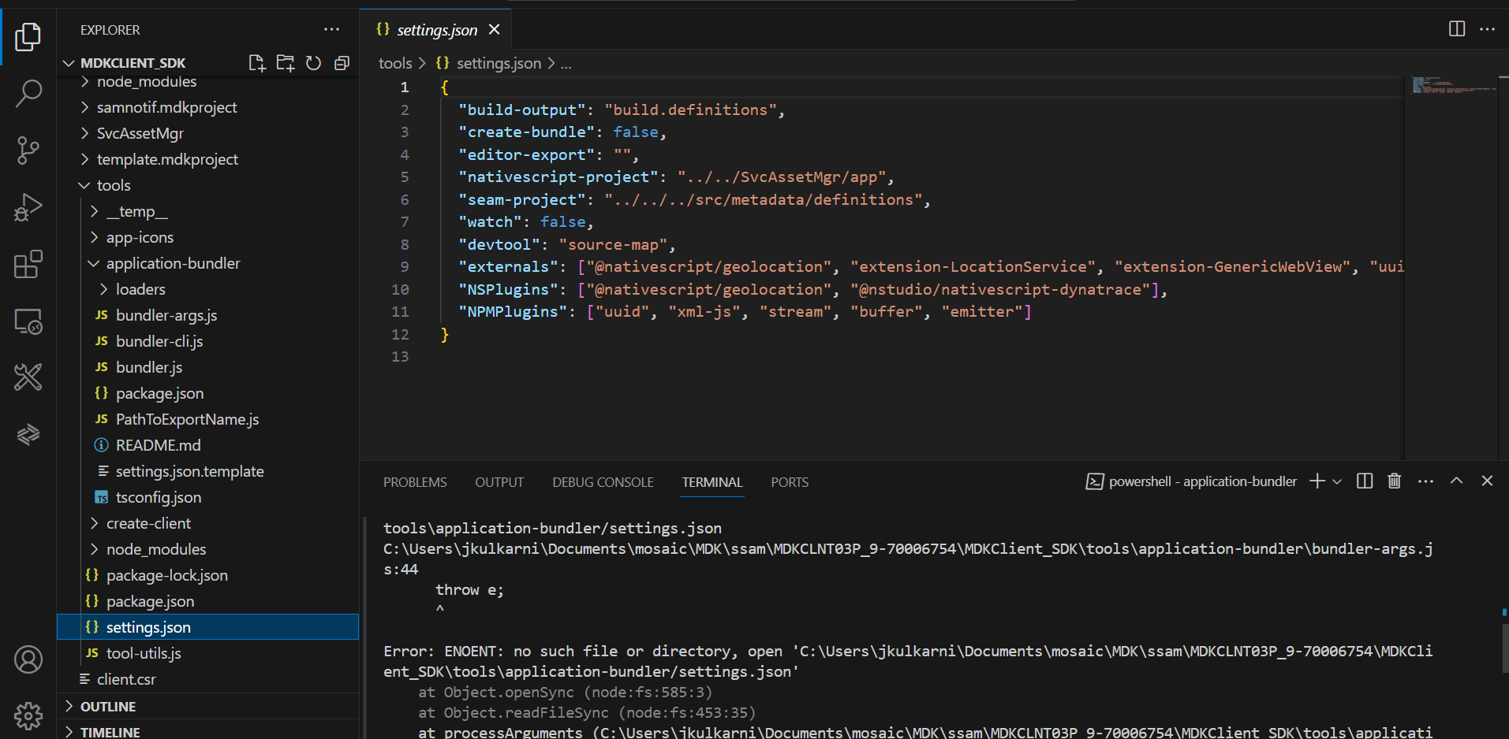

PS C:\Users\jkulkarni\Documents\mosaic\MDK\ssam\MDKCLNT03P_9-70006754> pushd MDKClient_SDK/tools/application-bundler
PS C:\Users\jkulkarni\Documents\mosaic\MDK\ssam\MDKCLNT03P_9-70006754\MDKClient_SDK\tools\application-bundler> node bundler-cli.js
trying to use settings file at C:\Users\jkulkarni\Documents\mosaic\MDK\ssam\MDKCLNT03P_9-70006754\MDKClient_SDK\tools\application-bundler/settings.json
failed to parse settings file with path C:\Users\jkulkarni\Documents\mosaic\MDK\ssam\MDKCLNT03P_9-70006754\MDKClient_SDK\tools\application-bundler/settings.json
C:\Users\jkulkarni\Documents\mosaic\MDK\ssam\MDKCLNT03P_9-70006754\MDKClient_SDK\tools\application-bundler\bundler-args.js:44
throw e;
^

Error: ENOENT: no such file or directory, open 'C:\Users\jkulkarni\Documents\mosaic\MDK\ssam\MDKCLNT03P_9-70006754\MDKClient_SDK\tools\application-bundler/settings.json'
at Object.openSync (node:fs:585:3)
at Object.readFileSync (node:fs:453:35)
at processArguments (C:\Users\jkulkarni\Documents\mosaic\MDK\ssam\MDKCLNT03P_9-70006754\MDKClient_SDK\tools\application-bundler\bundler-args.js:41:31)
at Object.<anonymous> (C:\Users\jkulkarni\Documents\mosaic\MDK\ssam\MDKCLNT03P_9-70006754\MDKClient_SDK\tools\application-bundler\bundler-args.js:191:1)
at Module._compile (node:internal/modules/cjs/loader:1103:14)
at Object.Module._extensions..js (node:internal/modules/cjs/loader:1157:10)
at Module.load (node:internal/modules/cjs/loader:981:32)
at Function.Module._load (node:internal/modules/cjs/loader:822:12)
at Module.require (node:internal/modules/cjs/loader:1005:19)
at require (node:internal/modules/cjs/helpers:102:18) {
errno: -4058,
syscall: 'open',
code: 'ENOENT',
path: 'C:\\Users\\jkulkarni\\Documents\\mosaic\\MDK\\ssam\\MDKCLNT03P_9-70006754\\MDKClient_SDK\\tools\\application-bundler/settings.json'
}
PS C:\Users\jkulkarni\Documents\mosaic\MDK\ssam\MDKCLNT03P_9-70006754\MDKClient_SDK\tools\application-bundler>

